#
# 20210129
#
# FreeIPA Client was not installed successfully.

[support@centos stash.tcsbank.ru]$ export ANSIBLE_CONFIG=ansible.cfg ; logfile="$(date +%Y%m%d-%H%M).playbook.log.txt" ; ansible-playbook 20191216-1721.install.freeipa-client.yml -i list_of_hosts --become --extra-vars "ansible_user=bsv ansible_password=$(pass common/linux) ansible_sudo_pass=$(pass common/linux) ansible_ssh_common_args='-oStrictHostKeyChecking=no -oPubkeyAuthentication=no -oUserKnownHostsFile=/dev/null'" 2>&1 | tee -a /tmp/${logfile} ; cp /tmp/${logfile} ./output/${logfile}
...
TASK [ans_int/freeipa-client : Main | Join server to FreeIPA domain] *************************************************************************************************************************
Friday 29 January 2021 13:10:50 +0300 (0:00:01.518) 0:00:15.633 ********
fatal: [ds-ira09]: FAILED! => {"censored": "the output has been hidden due to the fact that 'no_log: true' was specified for this result", "changed": true}
fatal: [m1-ira09]: FAILED! => {"censored": "the output has been hidden due to the fact that 'no_log: true' was specified for this result", "changed": true}
...

#
# Here I wrote no_log: false
# And start again.
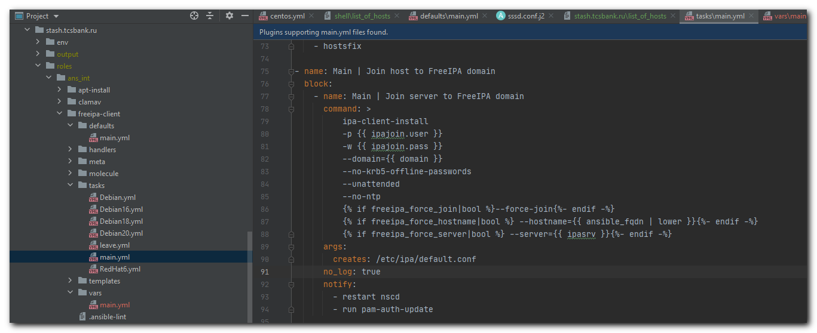

#
# Follow are more detailed descriptions.
#

fatal: [m1-ira09]: FAILED! => {"changed": true, "cmd": ["ipa-client-install", "-p", "s_s.belogrud", "-w", "IREzA1zq1", "--domain=unix.tcsbank.ru", "--no-krb5-offline-passwords", "--unattended", "--no-ntp", "--force-join"], "delta": "0:00:01.110193", "end": "2021-01-29 13:16:22.645176", "msg": "non-zero return code", "rc": 1, "start": "2021-01-29 13:16:21.534983", "stderr": "Discovery was successful!\nClient hostname: m1-ira09.tcsbank.ru\nRealm: UNIX.TCSBANK.RU\nDNS Domain: unix.tcsbank.ru\nIPA Server: m1-freeipa01p.unix.tcsbank.ru\nBaseDN: dc=unix,dc=tcsbank,dc=ru\nSkipping synchronizing time with NTP server.\nPlease make sure the following ports are opened in the firewall settings:\n TCP: 80, 88, 389\n UDP: 88 (at least one of TCP/UDP ports 88 has to be open)\nAlso note that following ports are necessary for ipa-client working properly after enrollment:\n TCP: 464\n UDP: 464, 123 (if NTP enabled)\nInstallation failed. Rolling back changes.\nUnconfigured automount client failed: Command '/usr/sbin/ipa-client-automount --uninstall --debug' returned non-zero exit status 1\nDisabling client Kerberos and LDAP configurations\nRedundant SSSD configuration file /etc/sssd/sssd.conf was moved to /etc/sssd/sssd.conf.deleted\nnscd daemon is not installed, skip configuration\nnslcd daemon is not installed, skip configuration\nClient uninstall complete.\nKerberos authentication failed: kinit: Password incorrect while getting initial credentials\n\nThe ipa-client-install command failed. See /var/log/ipaclient-install.log for more information", "stderr_lines": ["Discovery was successful!", "Client hostname: m1-ira09.tcsbank.ru", "Realm: UNIX.TCSBANK.RU", "DNS Domain: unix.tcsbank.ru", "IPA Server: m1-freeipa01p.unix.tcsbank.ru", "BaseDN: dc=unix,dc=tcsbank,dc=ru", "Skipping synchronizing time with NTP server.", "Please make sure the following ports are opened in the firewall settings:", " TCP: 80, 88, 389", " UDP: 88 (at least one of TCP/UDP ports 88 has to be open)", "Also note that following ports are necessary for ipa-client working properly after enrollment:", " TCP: 464", " UDP: 464, 123 (if NTP enabled)", "Installation failed. Rolling back changes.", "Unconfigured automount client failed: Command '/usr/sbin/ipa-client-automount --uninstall --debug' returned non-zero exit status 1", "Disabling client Kerberos and LDAP configurations", "Redundant SSSD configuration file /etc/sssd/sssd.conf was moved to /etc/sssd/sssd.conf.deleted", "nscd daemon is not installed, skip configuration", "nslcd daemon is not installed, skip configuration", "Client uninstall complete.", "Kerberos authentication failed: kinit: Password incorrect while getting initial credentials", "", "The ipa-client-install command failed. See /var/log/ipaclient-install.log for more information"], "stdout": "", "stdout_lines": []}

#
# I updated my FreeIPA password in file vars/main.yml
# And after that everything become - OK.

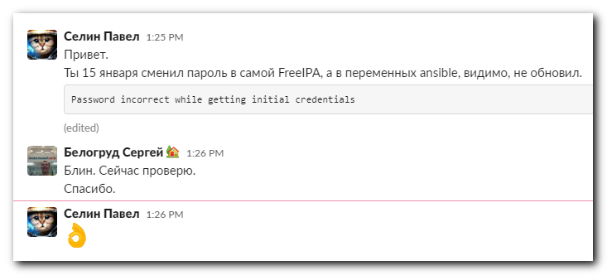

Oct 8, 2021
#
# Пароль freeipa учётки s_s.belogrud нужно генерировать без спец-символов!
# Иначе Паши Селина ansible-роль не будет серверы в freeipa вводить!
#

[support@nb2339]# pwd
/mnt/c/data/work/ansible/gitlab.tcsbank.ru
[support@nb2339]#

[support@nb2339]# export ANSIBLE_CONFIG=ansible.cfg ; logfile="$(date +%Y%m%d-%H%M).playbook.log.txt" ; ansible-playbook 20211008-1931.freeipa-client.yml -i list_of_hosts --become --extra-vars "ansible_user=root ansible_password=$(pass common/linux-root) ansible_ssh_common_args='-oStrictHostKeyChecking=no -oPubkeyAuthentication=no -oUserKnownHostsFile=/dev/null'" | tee -a ./output/${logfile}
...
TASK [das/freeipa-client : Join | Join server to FreeIPA domain] *********************************************************************Friday 08 October 2021 20:13:37 +0300 (0:00:03.641) 0:00:33.699 ********
fatal: [ds-hlr-db02]: FAILED! => changed=true
censored: 'the output has been hidden due to the fact that ''no_log: true'' was specified for this result'
to retry, use: --limit @/mnt/c/data/work/ansible/gitlab.tcsbank.ru/retry/20211008-1931.freeipa-client.retry

PLAY RECAP ***************************************************************************************************************************ds-hlr-db02 : ok=13 changed=0 unreachable=0 failed=1 skipped=2 rescued=0 ignored=0

[root@ds-hlr-db02 ~]# tail -n 10 /var/log/ipaclient-install.log
File "/usr/lib/python2.7/site-packages/ipaclient/install/client.py", line 2391, in install
_install(options)
File "/usr/lib/python2.7/site-packages/ipaclient/install/client.py", line 2545, in _install
rval=CLIENT_INSTALL_ERROR)

2021-10-08T17:14:21Z DEBUG The ipa-client-install command failed, exception: ScriptError: Kerberos authentication failed: kinit: Password incorrect while getting initial credentials

2021-10-08T17:14:21Z ERROR Kerberos authentication failed: kinit: Password incorrect while getting initial credentials

2021-10-08T17:14:21Z ERROR The ipa-client-install command failed. See /var/log/ipaclient-install.log for more information
[root@ds-hlr-db02 ~]#

